Structured Output in LangChain
https://www.youtube.com/watch?v=y5EmRr1O1h4&list=PLKnIA16_RmvaTbihpo4MtzVm4XOQa0ER0&index=7
https://github.com/campusx-official/langchain-structured-output
00:00 – Intro
01:13 – Recap
02:09 - What is Structured Output?
05:17 - Why do we need structured output?
11:40 - Ways to get structured output
14:08 - with_structured_output function
15:33 – TypedDict
36:07 – Pydantic
01:02:32 – JSON
01:02:58 - When to use?
01:04:53 - Important Points
01:07:47 – Outro
1. Introduction – Why Structured Output Matters in GenAI
Till now, most people think of LLMs as systems that talk to humans.
You give text → you get text back.
But here’s the real question this video starts with:
What if an LLM could talk not just to humans, but also to other machines and systems?
For example:
- LLM talking directly to a database
- LLM sending valid data to an API
- LLM controlling tools inside an application
This idea is foundational for advanced GenAI systems like Agents, which is why the instructor stresses that this topic is extremely important and should not be skipped.
The core motivation:
- Human ↔ LLM communication is already solved
- LLM ↔ System communication needs structured data
That’s where Structured Output comes in.

2. Recap – From Inputs to Outputs
In the previous video, we focused on prompts.
Key recap:
- Prompts are the inputs we give to LLMs
- We learned how to design prompts using:
  - Static prompts
  - Dynamic prompts
  - Prompt templates
  - Chat prompt templates
So far, our learning was mainly about:
“How do we send better input to the LLM?”
This video shifts the focus to:
“How do we handle the output coming from the LLM?”
And not just read it—but process it programmatically.

3. What Is Structured Output?
3.1 Unstructured Output (Default LLM Behavior)
Most LLMs return plain text.
Example:
- Prompt: What is the capital of India?
- Response: New Delhi is the capital of India.
This output:
- Is human-readable
- But has no fixed structure
- Is difficult for machines to reliably parse
This is called Unstructured Output.

3.2 Structured Output (What We Actually Want)
Now imagine asking an LLM:
Create a one-day travel itinerary for Paris
Instead of a paragraph, the LLM returns:
- A list of activities
- Each activity has:
  - Time
  - Activity name
In a format like:
- JSON
- Dictionary
- Defined schema
This is Structured Output.
Definition (LangChain context):
Structured output means forcing the language model to return data in a well-defined format, not just free-form text.

4. Why Structured Output Is So Powerful
The biggest advantage:
Structured output is easy for code to work with
Once the output has structure:
- You can store it in a database
- You can pass it to APIs
- You can feed it into tools
- You can build automation on top of it
This is the bridge between:
- LLMs
- Real-world software systems

5. Why Do We Need Structured Output? (Core Use Cases)
5.1 Data Extraction (Industry-Relevant Use Case)
Example: Job Portals (Naukri, LinkedIn, Indeed)
Scenario:
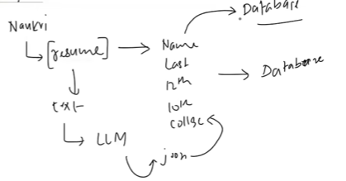
- User uploads a resume (PDF / text)
- You want to extract:
  - Name
  - Education details
  - Marks
  - Previous company
Flow:
- Resume text give it to→ LLM
- LLM extracts the above required info in JSON format
- JSON stored → Database
Without structured output:
- Parsing text is unreliable
- Edge cases break the system
With structured output:
- Clean
- Predictable
- Production-ready

5.2 Building APIs on Top of LLMs
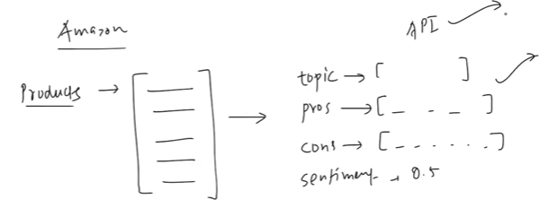
Example: Product Review Analysis (Amazon-like systems)
Reviews are:
- Long
- Text-heavy
- Unstructured
You can use structured output to extract:
- Topics discussed (battery, display, performance)
- Pros
- Cons
- Overall sentiment
Once structured:
- You expose this via an API (FastAPI / Flask)
- Any frontend or service can consume it
- This structured information can be used by anyone
This is how LLMs become backend services, not just chatbots.

5.3 Building Agents (Very Important for Future Topics)
Agents are:
- Chatbots plus the ability to take actions
Example:
- Math agent
- Customer support agent
- Finance agent
Problem:
- Tools like calculators, databases, APIs do not understand text
- They need numbers, keys, parameters
Structured output solves this by:
- Extracting exact parameters from text
- Passing them to tools correctly
This is why:
Agents are impossible to build properly without structured output

6. The Big Picture So Far
Earlier:
- Humans ↔ LLM (text ↔ text)
Now:
- LLM ↔ Databases
- LLM ↔ APIs
- LLM ↔ Tools
- LLM ↔ Other machines
All of this becomes possible because of structured output.
That’s why this topic is described as:
- Fundamental
- Non-skippable
- Critical for advanced GenAI systems

7. Ways to Get Structured Output (Conceptual Overview)
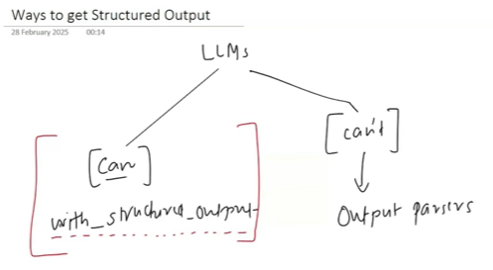
There are two types of LLMs:
7.1 Models That Support Structured Output Natively
- Example: OpenAI GPT models
- Can follow schemas if instructed properly
- LangChain provides with_structured_output() for this
7.2 Models That Do NOT Support It Natively
- Output is always plain text
- LangChain uses Output Parsers to convert text → structure
👉 This video focuses on the first category
👉 The next video will cover Output Parsers

8. with_structured_output() – High-Level Idea
The idea is simple:
- Define the output format
- Attach it to the model using with_structured_output
- Invoke the model
- Receive structured data instead of raw text
Ways to define structure:
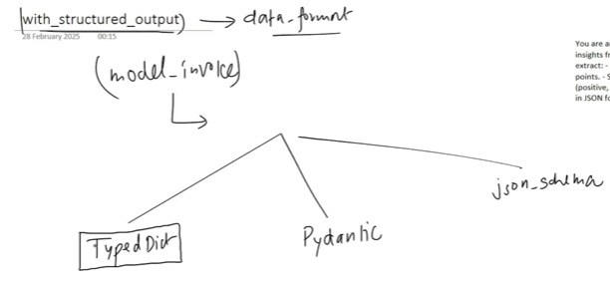
- TypedDict
- Pydantic
- JSON Schema

9. TypedDict – Defining Structure for LLM Outputs
TypedDict is a Python feature that allows you to define the expected structure of a dictionary, including:
Person A might be forming the dictionary having age as int and Person B might be forming the dictionary having age as string as to maintain the uniformity we use TypedDict
- which keys must exist
- what data type each key should hold
In the context of Generative AI and LangChain, TypedDict is used to describe the schema of the output we want from an LLM.

10. Why TypedDict Is Important
In normal Python code, dictionaries are created dynamically, which can lead to inconsistencies in large or collaborative projects.
Example problem:
- One developer treats age as an integer
- Another treats age as a string
This can cause subtle runtime bugs.
TypedDict helps by:
- Clearly defining expected keys and types
- Improving IDE support and auto-completion
- Making contracts between developers explicit
However, TypedDict is not a validation tool.

11. Key Limitation of TypedDict (Very Important)
TypedDict does not enforce runtime validation.
Even if:
- age is defined as int
you can still assign:
- "35" (string)
Python will not throw an error.
So remember:
- TypedDict = structure + hints
- TypedDict ≠ validation
This distinction becomes crucial when dealing with LLM outputs.
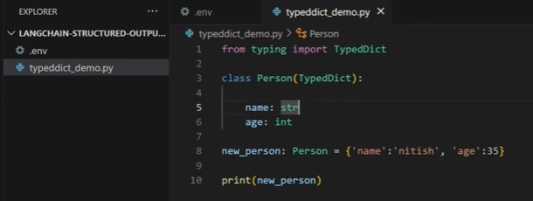

12. Using TypedDict with with_structured_output()
TypedDict becomes powerful when combined with LangChain’s with_structured_output().
Instead of receiving free-form text, the LLM returns a Python dictionary matching the TypedDict schema.
Example use case:
- Input: product review text
- Output:
  - summary
  - sentiment
This allows the output to be:
- programmatically parsed
- safely stored in databases
- sent to APIs or other systems
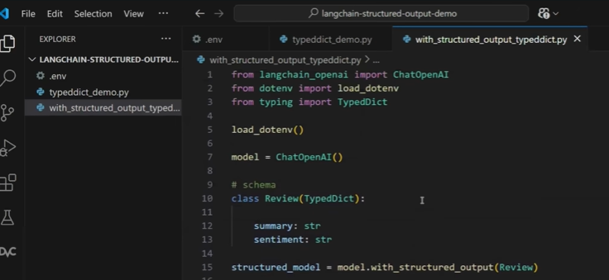
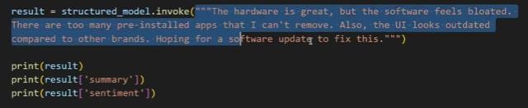
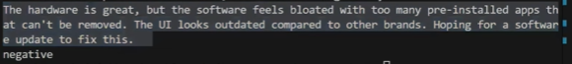

13. How with_structured_output() Works Behind the Scenes
When you call with_structured_output(schema):
- LangChain automatically generates a system prompt
- The prompt instructs the LLM to:
  - extract specific fields
  - follow the schema
  - return output in JSON format
Even if your user prompt does not explicitly ask for:
- “generate summary”
- “classify sentiment”
The schema itself acts as the instruction.
This abstraction hides complex prompt engineering and makes structured extraction feel effortless.
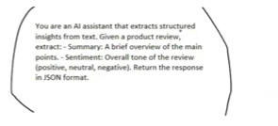

14. Improving Accuracy with Annotations (Annotated)
Sometimes, a key name like summary or sentiment might be ambiguous to the LLM.
To reduce ambiguity, you can use Annotated to add descriptions.
This helps the LLM understand:
- what kind of summary is expected
- what sentiment values represent
Annotations act like inline documentation for the model.

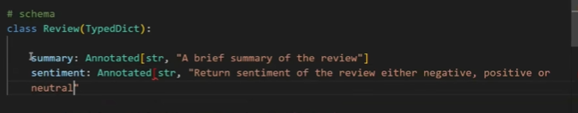

15. Handling Complex Outputs Using TypedDict
TypedDict supports more advanced output structures such as:
- Lists (e.g., multiple themes)
- Optional fields (e.g., pros or cons may not exist)
- Nested insights
Examples:
- themes: list of strings
- pros: optional list of strings
- cons: optional list of strings
This enables extraction of rich insights from long unstructured text like reviews, reports, or emails.
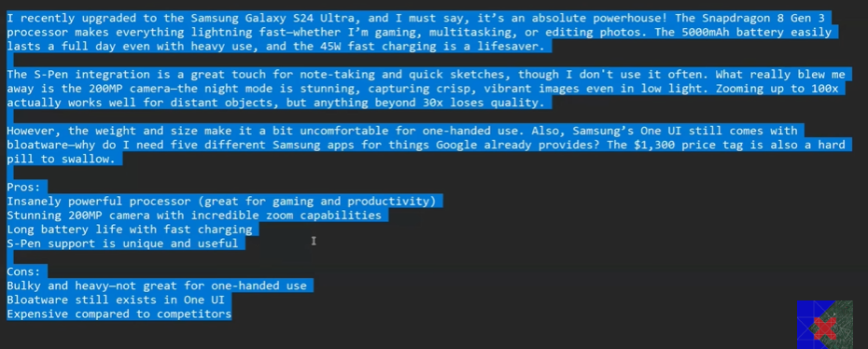
If some values are optional to generate
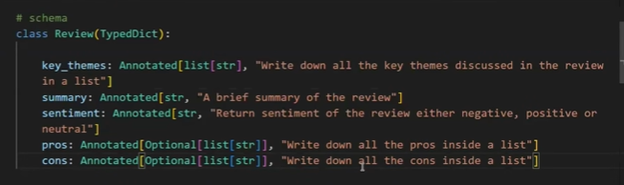
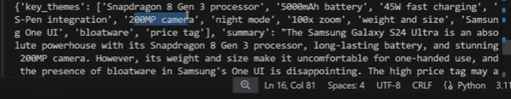

16. Restricting Output Values with Literal
Sometimes, downstream systems expect fixed values.
Example:
- Sentiment should only be "POS" or "NEG"
Using Literal:
- Restricts possible outputs
- Prevents unexpected values
- Makes integration with databases and APIs safer
This is extremely useful in production pipelines.

17. Optional Fields – When Data May Not Exist
LLMs may hallucinate missing information if not guided properly.
Using Optional:
- Tells the model that a field may or may not exist
- Prevents forced generation of fake data
- Improves output realism
However, proper prompting is still important to avoid hallucinations.
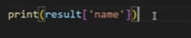
You get error if the name is not present
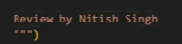
Add above line and run print then we can able to fetch

18. Why TypedDict Alone Is Not Enough
TypedDict helps define what the output should look like, but it cannot:
- enforce value constraints
- validate conditions
- throw errors on invalid output
For example:
- rating should only be included if > 3
- sentiment must strictly match allowed values
TypedDict cannot guarantee this.

20. What Is Pydantic and Why It Exists
Pydantic is a data validation and data parsing library for Python.
In simple terms, whenever data enters your system—
from APIs, databases, user input, or LLMs—you often want to ensure that:
- the data is of the correct type
- it follows certain rules
- invalid data is rejected immediately
Pydantic is designed exactly for this purpose.

21. Why Pydantic Is Critical in API and Production Systems
When building APIs (especially with FastAPI), validating incoming data is not optional—it’s essential for:
- security
- correctness
- predictable system behavior
That’s why FastAPI internally relies on Pydantic models.
In industry, unvalidated data is one of the biggest sources of bugs and vulnerabilities.

22. Relationship Between TypedDict and Pydantic
If you already understand TypedDict, Pydantic will feel familiar:
- Both define structured schemas
- Both use Python type hints
- Both improve developer experience
Key difference:
- TypedDict → structure + hints only
- Pydantic → structure + runtime validation + parsing
This makes Pydantic far more powerful.

23. Creating a Basic Pydantic Model
To use Pydantic, you first install it and import BaseModel.
A Pydantic schema is defined by:
- creating a class
- inheriting from BaseModel
- defining fields with types
At this stage, it looks like standard OOP, but the real power comes next.
Create a Student class inherited from the BaseModel and define name
Create new_student and assign the value then create a object of the class using this new_student
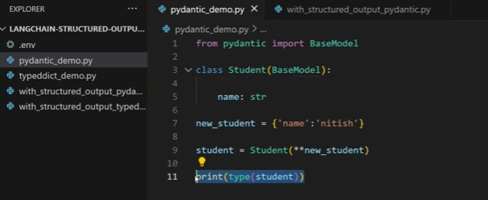
If instead of passing the name as string if we pass the integer it gives error
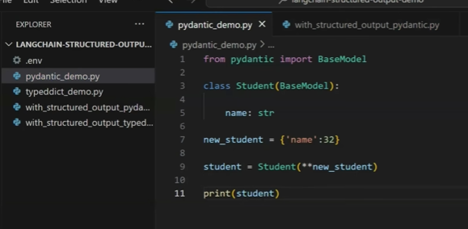
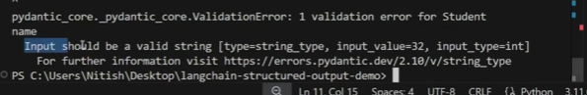

24. Automatic Runtime Validation
Unlike TypedDict, Pydantic actively validates data at runtime.
If a field is defined as str and an integer is passed:
- Pydantic raises an error
- object creation fails
- invalid data never enters your system
This is extremely important in production pipelines.

25. Why Runtime Validation Matters for LLM Outputs
LLMs can:
- hallucinate
- return wrong types
- violate assumptions silently
Using Pydantic ensures:
- structured outputs are trustworthy
- failures are caught early
- downstream systems remain stable
This is a must-have for real GenAI applications.

26. Default Values in Pydantic Models
Pydantic allows you to define default values for fields.
If data is missing:
- the default value is automatically applied
- object creation still succeeds
This is useful when:
- APIs send partial data
- LLM outputs omit non-critical fields
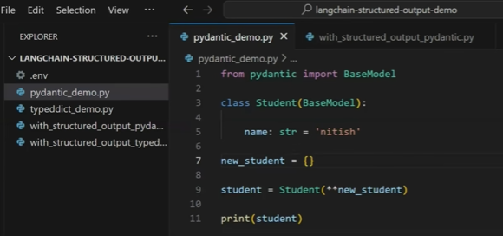

27. Attribute Access vs Dictionary Access
A Pydantic model instance:
- behaves like an object
- supports dot notation (student.name)
This improves:
- readability
- IDE auto-completion
- maintainability in large codebases

28. Optional Fields and Missing Data
In real-world data (and LLM responses), some fields may or may not exist.
Using Optional:
- explicitly allows missing fields
- prevents forced hallucination
- improves realism of outputs
However, optional fields must have a default value (usually None).
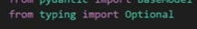
When the data is optional we assign by default none
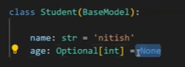
When we assign the age then it will be taken
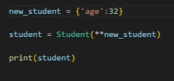

29. Implicit Type Conversion (Type Coercion)
Pydantic is intelligent enough to:
- convert compatible data types automatically
Example:
- "32" → int(32)
- "5.0" → float(5.0)
This makes systems more robust when dealing with imperfect inputs.
If we give age as string then implicit conversion happens and it will be converted into int


30. Built-in Validators (Email, URLs, etc.)
Pydantic provides built-in validated types like:
- EmailStr
- URL types
- constrained numbers and strings
These validators:
- enforce correctness
- reduce custom validation code
- increase security
Industry usage:
User registration systems, forms, API payloads, authentication flows.
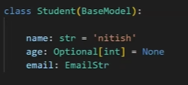
If we give the wrong email
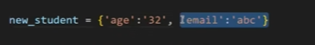
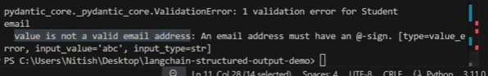
Give the right email
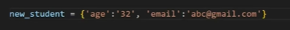
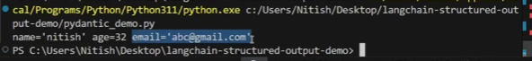

31. The Field() Function – Power Features
Field() allows you to:
- set default values
- add constraints (min, max, regex)
- add descriptions
- control validation behavior
This makes schemas both:
- machine-readable
- LLM-friendly
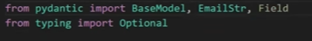
We can specify the range
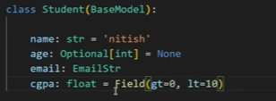
Value greater than range
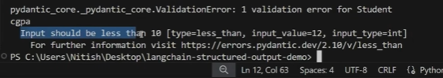
Assign default value
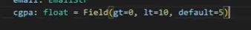

32. Adding Constraints Using Field()
Constraints ensure values fall within acceptable limits.
Example:
- CGPA must be between 0 and 10
- Age must be ≥ 18
- Rating must be between 1 and 5
If violated:
- Pydantic raises an error
- invalid data is rejected immediately

33. Descriptions Help LLMs Understand Better
Descriptions added via Field():
- act like inline documentation
- guide LLMs during structured output generation
This directly improves:
- extraction accuracy
- output consistency
This is especially useful with with_structured_output().

34. Regex Validation for Structured Fields
Pydantic allows regex constraints for fields like:
- phone numbers
- IDs
- codes
This prevents malformed inputs from ever entering your system.

35. Converting Pydantic Models to Dict or JSON
A Pydantic object can be converted to:
- Python dictionary
- JSON string
This flexibility is important because:
- APIs often require JSON
- databases may need dictionaries
- LLM pipelines may need raw objects
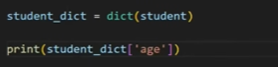

36. Why Conversion Matters in Real Systems
Different layers expect different formats:
- Backend logic → Pydantic objects
- API responses → JSON
- Analytics / storage → dict
Pydantic supports all of them cleanly.

37. Using Pydantic with with_structured_output()
Now comes the key integration.
Instead of TypedDict, you can pass:
- a Pydantic model
to with_structured_output().
Result:
- LLM output is validated
- schema rules are enforced
- errors surface immediately
This is production-grade structured generation.
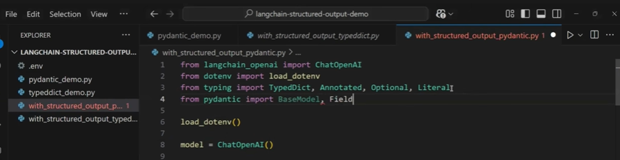
Convert the class for Pydantic
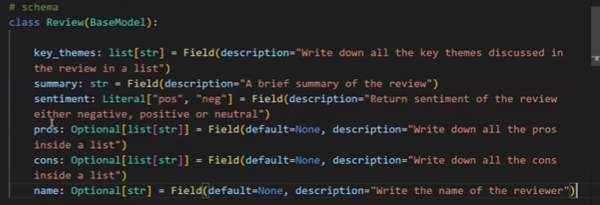
In TypedDict we used fetch the key but in pydantic we will fetch the objects
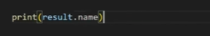

38. Replacing TypedDict with Pydantic in LLM Pipelines
The same schema used earlier (themes, summary, sentiment, pros, cons, name) is recreated using Pydantic.
Benefits:
- strict validation
- safer downstream processing
- fewer silent failures
This is why most real-world GenAI systems prefer Pydantic.

39. Understanding Output Type Differences
- TypedDict → returns a Python dictionary
- Pydantic → returns a Pydantic object
- JSON Schema → returns a dictionary
Knowing this avoids access-related bugs in production.

40. Why Pydantic Is More Powerful Than TypedDict
TypedDict:
- structure only
- no enforcement
Pydantic:
- structure
- validation
- constraints
- type coercion
- serialization
Industry preference: Pydantic.

41. When JSON Schema Is Required Instead
Pydantic and TypedDict are Python-specific.
JSON Schema is preferred when:
- multiple languages are involved
- backend is Python, frontend is JavaScript
- schemas must be shared across teams
JSON is a universal contract.

42. JSON Schema as a Cross-Language Contract
JSON Schema defines:
- data types
- required fields
- optional fields
- allowed values
Any language can:
- validate against it
- generate forms
- parse data safely
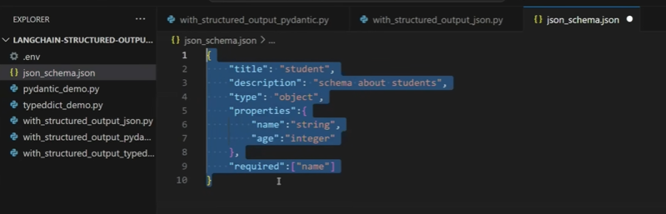

43. Using JSON Schema with LLM Structured Output
LangChain allows passing JSON Schema directly into with_structured_output().
Result:
- output is returned as a dictionary
- schema is language-agnostic
- ideal for distributed systems
Copy paste pydantic code – we will delete the pydantic schema where we add the json schema
Here we will create the json for each attribute: title, sentiment, pros, cons etc
To all this json we will give the name as json_schema
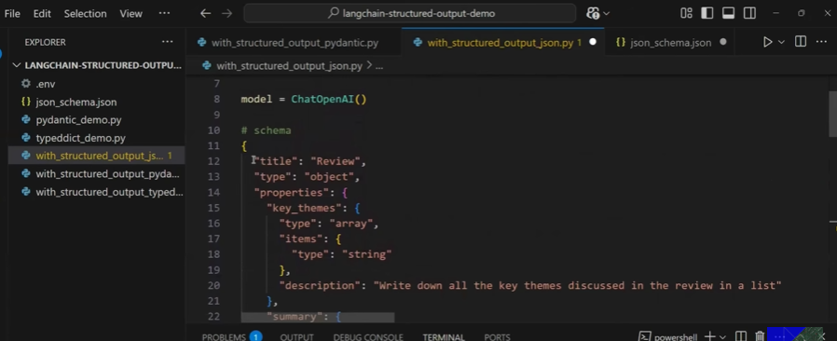
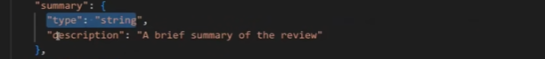
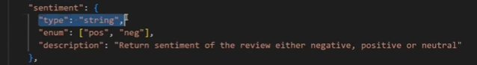
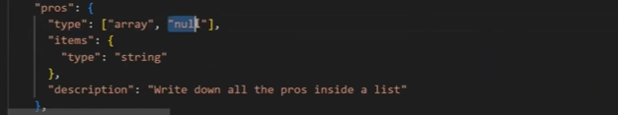
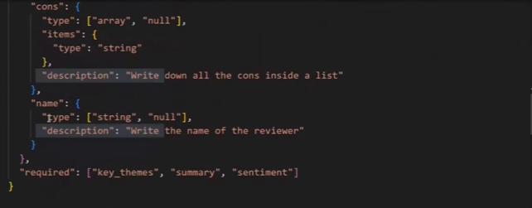

44. Choosing Between TypedDict, Pydantic, and JSON Schema
Rule of thumb:
- Quick prototype → TypedDict
- Python production system → Pydantic
- Multi-language system → JSON Schema
This decision matters in real-world architecture.

45. Final Takeaway from This Section
You now understand:
- why TypedDict is limited
- why Pydantic is production-ready
- when JSON Schema becomes necessary
These three form the core foundation of reliable structured LLM systems.

46. Three Ways to Define Structured Output Schemas
So far, we have seen three different schema formats to solve the same structured-output problem:
- TypedDict
- Pydantic
- JSON Schema
All three aim to enforce structure on LLM outputs, but they serve different real-world needs.
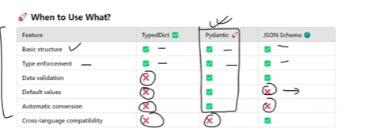

47. When to Use TypedDict
TypedDict should be used when:
- Your entire project is written in Python
- You only need type hints, not validation
- You do not need to share schemas with other languages
- You want a lightweight solution without extra dependencies
TypedDict is mostly helpful during:
- early experimentation
- quick prototyping
- internal Python-only tools
Industry reality:
TypedDict is rarely used alone in production GenAI systems.

48. When to Use Pydantic (Most Common Choice)
Pydantic is the right choice when:
- You are working primarily in Python
- You need data validation
- You want default values
- You want automatic type conversion
- You are handling unreliable LLM outputs
Pydantic solves problems that TypedDict cannot:
- runtime validation
- coercing string numbers to integers
- rejecting malformed data

49. Why Pydantic Is the Go-To in Real-World GenAI
Most GenAI backends today:
- are written in Python
- use FastAPI
- consume LLM outputs
- require strict guarantees
Because of this, Pydantic becomes the default schema format for:
- structured LLM pipelines
- API validation
- production-ready AI systems
This is why the course emphasizes Pydantic heavily.

50. When to Use JSON Schema
JSON Schema is used when:
- Your project involves multiple languages
- Backend is Python, frontend is JavaScript
- Schemas must be shared across teams
- You want a language-agnostic contract
JSON Schema does not depend on Python at all.

51. JSON Schema as a Universal Contract
JSON is understood by:
- Python
- JavaScript
- Java
- Go
- C#
- Mobile frameworks
Because of this, JSON Schema becomes the single source of truth in distributed systems.
Industry example:
- Python backend generates schema
- React frontend validates forms
- Mobile app validates payloads
- LLM outputs are parsed consistently everywhere

52. Feature Comparison Summary (Mental Model)
Think of it this way:
- TypedDict → structure only
- Pydantic → structure + validation + conversion
- JSON Schema → cross-language structure
This mental model helps you choose quickly.

53. Why the Course Focuses on Pydantic
Since most learners:
- build GenAI systems in Python
- deploy APIs
- integrate LLMs with backend logic
Pydantic becomes the best default choice for structured output.

54. with_structured_output() – Method Parameter
When calling with_structured_output(), you can specify how the structure is enforced using the method parameter.
Two options exist:
- JSON mode
- Function calling mode
- 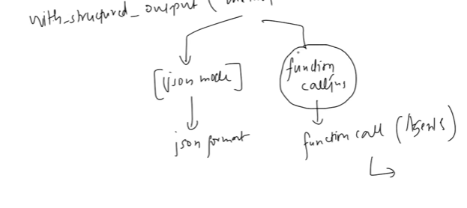

55. JSON Mode Explained
Use JSON mode when:
- you want the LLM to return valid JSON
- you plan to parse the output directly
- the model supports JSON output
This is the most common use case.

56. Function Calling Mode Explained
Use function calling when:
- the structured output is meant to trigger an action
- the LLM should call a tool or function
- you are building agents
Example tools:
- calculator
- search
- database query
- API call

57. Agents and Function Calling in Industry
In agent-based systems:
- LLM decides what to do
- structured output defines which function to call
- parameters are passed automatically
This is how:
- AI assistants
- autonomous agents
- tool-using chatbots
are built in production.

58. Model-Specific Recommendations
Rule of thumb:
- OpenAI models → Function calling (default & recommended)
- Gemini / Claude / other models → JSON mode
- Some open-source models → No structured output support

59. Not All Models Support Structured Output
Some models:
- do not support JSON mode
- do not support function calling
- cannot guarantee structured responses
Example shown:
- TinyLLaMA (open-source model)

60. What Happens When Structured Output Is Unsupported
If a model does not support structured output:
- with_structured_output() fails
- errors are thrown
- you must manually parse outputs
This is where output parsers become necessary.

61. Why This Matters in Production
In real systems:
- model capability directly affects architecture
- structured output support simplifies pipelines
- lack of support increases engineering complexity
Choosing the right model is not just about accuracy.

62. Key Learning from This Section
You now understand:
- how to choose between TypedDict, Pydantic, and JSON Schema
- when JSON mode vs function calling is required
- why some models fail with structured output
- how model choice impacts system design

63. Transition to the Next Topic
The next logical step is Output Parsers.
They are required when:
- structured output is unavailable
- models are inconsistent
- schemas must be enforced manually
This is exactly what the next video covers.

